**ANDREEV, Leonid Nikolaevich (АНДРЕЕВ, ЛЕОНИД НИКОЛАЕВИЧ) (1871-1919)**

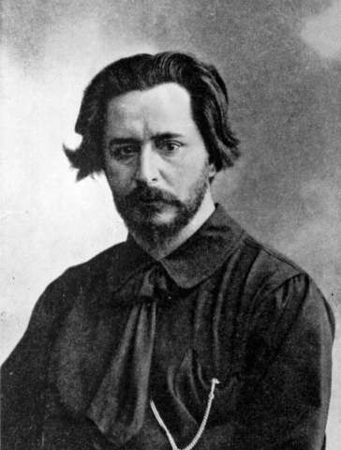A prolific Russian author, widely popular in the first decade of the 20th century, whose fictional and dramatic works spanned the divide between realism and symbolism. Born in Orel, a provincial capital south of Moscow, he died in Finland. Andreev studied law in St. Petersburg and Moscow. After a brief and unsuccessful legal career, he worked as a journalist, prose writer, and dramatist, quickly making a name for himself as a successful short story writer after his stories began to appear in newspapers. His first published volume of stories (1901) was an immediate success, with its first two printings selling out in two weeks. He turned to playwriting five years later, although he continued to write short stories until late in life. Andreev’s creative work sparked much debate from both realist and symbolist writers. He developed a close friendship with realist writer Maxim Gorky, although the two grew to disagree about questions of literary style and politics, as Andreev’s work strayed from its early realist tendencies and tended not to convey strong revolutionary ideals. Gorky mentored Andreev in his early career and spearheaded a collection of literary reminiscences by famous writers upon the latter’s death. Andreev’s popularity waned along with his health during the final decade of his life.

**References and Further Reading:**

Davies, Richard, ed. (1989). *Photographs by a Russian Writer: An Undiscovered Portrait of Pre-Revolutionary Russia.* London: Thames and Hudson. Essays on Andreev’s life, interspersed with photographs taken by Andreev and collected by his family.

Hutchings, Stephen (1990). *A Semiotic Analysis of the Short Stories of Leonid Andreev 1900-1909.* London: The Modern Humanities Research Association. Somewhat difficult text, includes a selected bibliography of Russian- and English-language sources.

Kaun, Alexander (1924). *Leonid Andreyev: A Critical Study.* New York: Benjamin Blom. Reissued in 1969. Includes an extensive bibliography of early-20th century texts on Andreev.

Newcombe, Josephine M. (1972). *Leonid Andreyev.* Letchworth, England: Bradda Books. A short and accessible introduction to Andreev’s life and creative work.

White, Frederick H. (2006). *Memoirs and Madness: Leonid Andreev through the Prism of the Literary Portrait.* Montreal and Kingston: McGill-Queen’s UP. Includes an annotated translation of *A Book about Leonid Andreev* (1922), which offers remembrances of Andreev penned by Maxim Gorky, Aleksandr Blok, Evgeny Zamyatin, Andrei Bely, and other contemporaries.

Woodward, James B. (1969). *Leonid Andreyev: A Study.* Oxford: Clarendon Press. A comprehensive study of Andreev’s life, creative work, influences, and political views.

**Major Works:**

**Stories:**

“Bezdna” (“The Abyss”) [1902]. Considered to be a response to Lev Tolstoi’s *Kreutzer Sonata*, this story deals with violent sexual impulses, and depicts an adolescent who rapes his girlfriend. It was widely debated in its time due to its controversial subject matter.

“V tumane” (“In the Fog”) [1902]. Along with “The Abyss,” this story made a name for Andreev as a controversial writer. In this story, a young man wanders through the fog of city streets, eventually killing a prostitute and himself after an encounter.

“Krasnyi smekh” (“Red Laugh”) [1904]. Written after the outbreak of WWI, this story was experimental in form, and intended to convey a sense of the psychological damage wrought by war.

“Rasskaz o semi poveshennykh” (“The Story of Seven Who Were Hanged”) [1908]. Considered Andreev’s finest story, this work portrays the inhumanity of the death penalty. It was translated into multiple languages and had sold 100,000 copies by 1911.

**Plays:**

*Zhizn’ cheloveka* (*Life of Man*) [1906]. Allegoric play in five “pictures,” each representing a different stage in a man’s life, from birth to death. Notably, both Vsevolod Meyerhold (St. Petersburg) and Konstantin Stanislavsky (Moscow) produced this play in 1907.

*Tot, kto poluchaet poshchechiny* (*He Who Gets Slapped*) [1916]. Andreev’s most widely known play outside of Russia, this complex play is set in a circus following the arrival of a mysterious newcomer. The play blends social polemic with mythical overtones.

**Jessica Hinds-Bond, Northwestern University**

Source url for image:

<http://www.andreef.com/gallery/big/02.jpg>